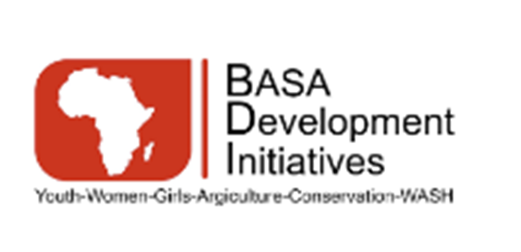
BASA DEVELOPMENT INITIATIVES
CODE OF CONDUCT

(Including Prevention of Sexual Exploitation and Abuse – PSEA)
Effective Date: 15 January 2026
Approved by: Board of Directors
Applies to: All personnel under any contract modality

1. Purpose and Commitment
BASA Development Initiatives (BDI) is committed to conducting all its work with integrity, professionalism, respect, and accountability. This Code of Conduct sets out the minimum standards of behaviour expected of all personnel representing or acting on behalf of BDI. It reflects BDI’s zero-tolerance approach to sexual exploitation and abuse and its commitment to safeguarding children and adult beneficiaries, upholding human dignity, and maintaining the trust of communities, partners, and donors. All personnel are required to understand, sign, and comply with this Code as a condition of engagement with BDI.

2. Scope and Applicability
This Code of Conduct applies to all individuals working for or representing BDI, regardless of contract modality or role. This includes permanent and temporary staff, consultants, volunteers, interns, board members, advisors, partner personnel working under BDI-led activities, and any other affiliated individuals. The Code applies at all times, both during and outside working hours, whenever an individual’s conduct may impact BDI’s work, reputation, or beneficiaries.

3. Core Principles of Conduct
All personnel must act in a manner that:
- Respects the dignity, rights, and well-being of all people, especially women and children
- Avoids abuse of power, trust, or position
- Prevents harm to beneficiaries, especially children and vulnerable persons
- Upholds confidentiality, impartiality, and professionalism
- Complies with applicable laws, donor requirements, and BDI policies

4. Definitions
Sexual Exploitation means any actual or attempted abuse of a position of vulnerability, differential power, or trust for sexual purposes, including profiting monetarily, socially, or politically from the sexual exploitation of another.

Sexual Abuse means actual or threatened physical intrusion of a sexual nature, whether by force or under unequal or coercive conditions.

Sexual Exploitation and Abuse (SEA) refer to acts committed against beneficiaries or members of the communities where BDI operates.

Sexual Harassment refers to unwelcome sexual conduct between personnel or in the workplace. While sexual harassment is also prohibited, it is distinct from SEA and addressed through separate internal procedures.

Child means any person under the age of 18, regardless of local age of consent.

5. Prohibited Conduct: Sexual Exploitation and Abuse (SEA)
BDI strictly prohibits all forms of sexual exploitation and abuse. This prohibition applies at all times and under all circumstances.

Personnel must not:
- Engage in sexual activity with beneficiaries or community members where BDI operates
- Engage in sexual activity with a child under any circumstances
- Exchange money, employment, goods, services, assistance, or opportunities for sexual acts or favours
- Use their position to solicit or coerce sexual relationships
- Engage in exploitative or abusive relationships arising from unequal power dynamics
- Facilitate, condone, or fail to report SEA committed by others
Consent is not a defence where there is an imbalance of power or where the individual is a beneficiary of assistance.

6. Other Prohibited Conduct
In addition to SEA, personnel must not:
- Engage in sexual harassment of colleagues or partners
- Exploit, abuse, or discriminate against any person
- Use threats, intimidation, or retaliation against anyone who raises concerns
- Misuse organizational resources for personal gain
- Engage in conduct that undermines trust with communities or partners

7. Reporting Obligations
All personnel have a mandatory obligation to report any suspicion, concern, allegation, or disclosure of sexual exploitation and abuse immediately through BDI’s reporting channels. Personnel must report:

- SEA committed by BDI personnel or partners
- SEA committed by other actors if observed in the course of BDI work
- Any behaviour that raises safeguarding concerns

Failure to report suspected SEA constitutes a serious breach of this Code.

8. Protection from Retaliation
BDI strictly prohibits retaliation against any individual who reports a safeguarding concern or cooperates in an investigation in good faith. Retaliation includes threats, intimidation, dismissal, demotion, harassment, or any form of disadvantage. Any act of retaliation will result in disciplinary action.

9. Cooperation with Investigations
All personnel are required to cooperate fully with safeguarding investigations, audits, and assessments conducted by BDI or authorized third parties. This includes providing truthful information and respecting confidentiality requirements. Obstructing or interfering with an investigation is considered misconduct.

10. Consequences of Breach
Violation of this Code of Conduct, particularly acts of sexual exploitation or abuse, constitutes gross misconduct and may result in:

- Immediate termination of employment or engagement
- Referral to national authorities
- Notification to donors or relevant oversight bodies
- Legal action where applicable

Disciplinary measures apply regardless of position or seniority.

11. Responsibility and Acknowledgement
All personnel are responsible for understanding and complying with this Code of Conduct. Managers and supervisors have an additional responsibility to model appropriate behaviour, promote safeguarding awareness, and ensure compliance within their teams.

12. Acknowledgement and Signature
I acknowledge that I have read, understood, and agree to comply with this Code of Conduct. I understand that failure to do so may result in disciplinary action, including termination of my engagement with BASA Development Initiatives.

Name:
Position / Role:
Signature:
Date:

